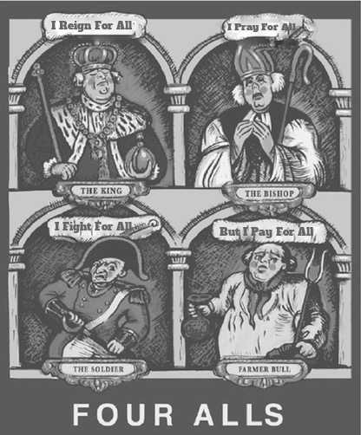
Lunch Menu

Soup of the day served with crusty bread roll (V) £4.95

Chicken liver brandy & herb pate served with caramelised red onion chutney and wholemeal toast £5.95

Classic chicken Caesar salad served with croutons £7.95

Breaded whitebait served with tartare sauce and lemon wedge £5.95

Battered cod strips served with garden peas and chips £8.95

Beef lasagne served with garlic bread and house salad £9.95

House burger – minted lamb or beef
(sautéed onions, cheese, tomato, lettuce and relish) served with chips and coleslaw £9.95

Chicken and mango curry served with half rice and half chips
£10.95

Home cooked ham, egg and chips £6.95

Butternut squash & goats cheese lasagne (V) £10.95

Side Orders

Coleslaw £1.95
Garlic bread £2.45 (with cheese +50p)
Chips £2.45
Fries £2.45
Onion rings £2.95
Salad £2.45
Vegetables £2.45

Sandwiches

All sandwiches are served with coleslaw & crisps and are made using a choice of thick cut white or wholemeal bread

Prawn & Marie Rose sauce £6.95
Chicken mayonnaise, lettuce & tomato £5.95
Tuna mayonnaise & cucumber £5.95
Home cooked ham with cheese and chutney £5.95
Cheese & onion £4.95

Jacket Potatoes

All jacket potatoes are served with coleslaw and salad garnish

Prawn & Marie Rose sauce £7.95
Chicken mayonnaise £6.95
Tuna mayonnaise £6.95
Baked beans & cheese £6.95
Cheese & onion £5.95

Children’s Menu

Ham, egg and chips £4.95
Sausage, mashed potatoes and vegetables £5.95
Battered cod, chips and peas or beans £5.95
Breaded chicken pieces, chips and peas or beans £4.95
Soup of the day with crusty bread roll £2.95
Chicken Caesar salad £4.95

Desserts

Crème brûlée £4.50
Sticky toffee pudding served with cream, ice cream or custard £4.50
Chocolate brownie served with cream, ice cream or custard £4.50
Eton mess £4.50
Selection of ice creams £3.95

Please order at the bar with your table number,
thank you!

Food allergens and intolerances,
before ordering drinks or food please speak with a member of our team about your requirements

